American college football

I chose the resolution which gave me 3 communities. I found it makes sense since we can see a division of three geographic regions of colleges. The blue nodes denote colleges in the West; the orange nodes denote colleges in the Midwest, and the green nodes denote colleges in the South.

The size of the nodes denote the level of betweenness centrality: Larger nodes suggest higher level of betweenness centrality. It seems that nodes with higher betweenness centrality tend to on the border of two communities.

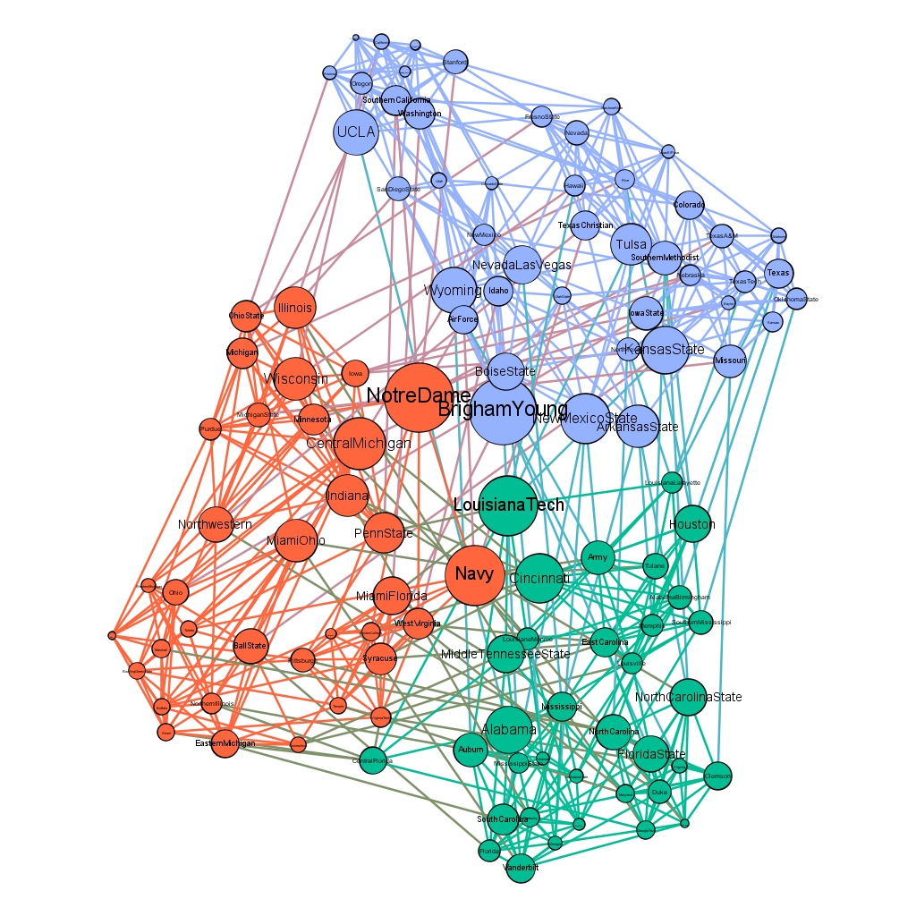

Political blogs

The graph below shows a directed network of hyperlinks between weblogs on US politics. The giant component shows a two-community structure, which, I believe, represents weblogs related to Republican and Democratic parties.

The size of the nodes denote the level of eigenvector centrality: Larger nodes suggest higher level of eigenvector centrality. It seems that nodes with higher eigenvector centrality tend to on the border of two communities.

